

**GROUP MEMBERS:**

**GOKUL R**

**SHANMUGA PRIYAN T**

**SHARANKANTH E**

**TABLE OF CONTENTS**

**ABSTRACT**

1.Introduction ……………………………………………………………..……………………………………………………………01

2. Review 1 (Survey, Analysis)...…………………………….……….…………………………………………………….05

3. Review 2 (Design of Diagrams & Prototype Design)………………………………………………………13

4. Review 3 (Development of Model).....…………………………………. .………………………………………….21

5. Conclusion ………………………………………………………....…………………………………………………………………30

6. References ………………………………………………………….…………………………………………….…………………. 12

**ABSTRACT:**

**Discord** started in 2012 as a voice chat app for gamers who communicated with each other through [gaming terminologies](https://slotsroll.co.uk/blog/video-game-gambling/). It was known to only a select range of people and for most of us normies, the app was unheard of. Cut to 2020, when the entire world was stuck in their houses, thanks to a deadly [pandemic](https://businessupside.com/2020/10/09/top-10-free-games-to-play-online-during-the-pandemic/), Discord had a boom. Discord was initially for gamers to connect and play along and for joining gaming communities. It has voice channels so that players can play along. But Discord has changed a lot and people use Discord for general purposes and not just gaming. Suddenly, everyone from a gamer to a non-gamer made their way to the app and found their distinct community. Whether it was about hosting a community gathering digitally, or organizing a study session, or simply, vibing with your kind of people over similar tastes in music**, Discord** came in handy. Within a matter of no time, Discord now proudly boasts of a user base of 140 million.

Discord is a voice/video chatting app that was created for the **gaming community**. It now caters to absolutely any and every community out there. Discord is a communication application that is made on the idea of guilds which are called “servers” in Discord. It is primarily divided into servers which are run by its own set of rules, members, channels, and topics. Discord does not only limit itself to being a voice and video chatting app, but also helps in live streaming of games, [movies](https://businessupside.com/2020/11/19/movie-time-7-best-way-to-watch-movies-together-online/), concerts, and other events. The app saw its highest-ever user base of about 140 billion people in 2020 and it has been growing ever since. In the context of a global pandemic, the app has become indispensable for people who need to constantly be in touch. With its ever-growing user base, the app assumed a simple tagline which helped in rebranding it in a completely new light- “Your place to talk”. This simple message helped shed its earlier identity as an app just for gamers and opened its doors to every person out there with a non-gaming interest. In 2020, about seventy percent of the users reported belonging to a non-gaming community, thus making the tagline worthwhile.

**INTRODUCTION:**

Discord is a communication application that is made on the idea of guilds which are called “servers” in Discord. It is primarily divided into servers which are run by its own set of rules, members, channels, and topics. The app might look slightly obtuse for people coming from apps like Skype and [Zoom](https://businessupside.com/2020/09/21/zooms-skyrocketing-revenue-analysis/) where the functions work as they spell. Discord has an array of hidden features that can make the user experience bigger and better, which most existing people are unaware of. If a user wants to create a community of their friends, family, work colleagues, or just people of shared interest, they have to first set up their discord account. Then they have to simply add a server channel and customize accordingly. Then they could invite the desired people and the channel is good to go. If someone is not interested in creating their channel, they have a host of other channels to join from. They could discover several public servers by simply clicking on the bottom left corner of the screen. One can join gaming servers like Fortnite and Minecraft or simply log into the channel created by your favorite Instagrammer or [YouTuber](https://businessupside.com/2021/05/17/how-much-do-youtubers-make-a-beginners-question/). The channels become as varied as wall street conversations to beatboxing to fashion to dance groups discussing routines. People have known to teach the art of living through their servers too. Since discord allows one to share their screens, it’s perfect for hosting game nights or movie nights. One could also customize their servers by adding video or voice clips to their servers and employ a host of other tools to make their channel special. If the operations still feel a bit difficult, Discord’s Getting Started guide will be of immense help. Discord voice chat is among the most popular features of the app. The extremely good quality and low-frequency voice tool make the app very popular amongst game streamers like Twitch or people who have their podcasts. Once the user has everything set up according to their needs, they can chat, stream, send GIFs or simply listen to other people discuss their favorite topic on the app. Users mainly have live jamming sessions, have video gatherings through their video chat feature or grow their Twitch community. Discord has a place for every person with unique interests.

**2. Review-1 (Survey & Analysis)**

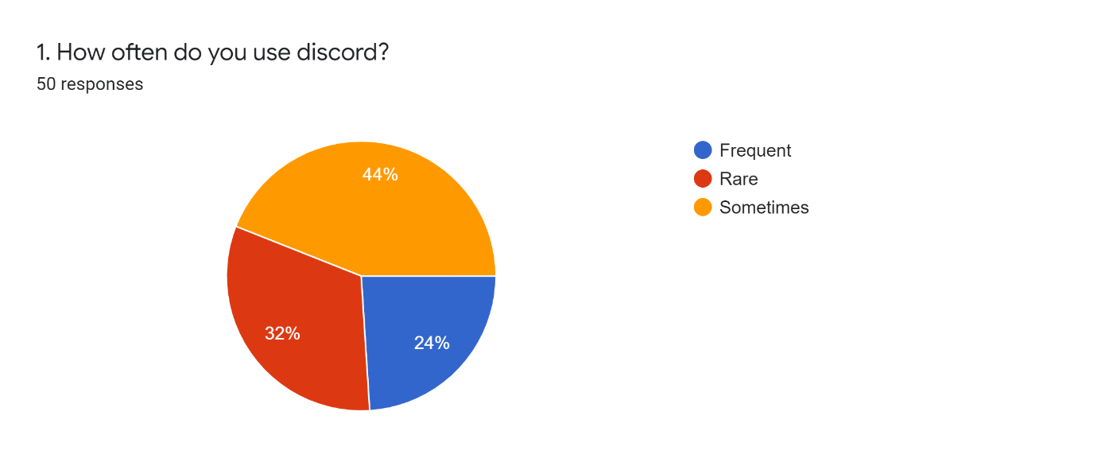

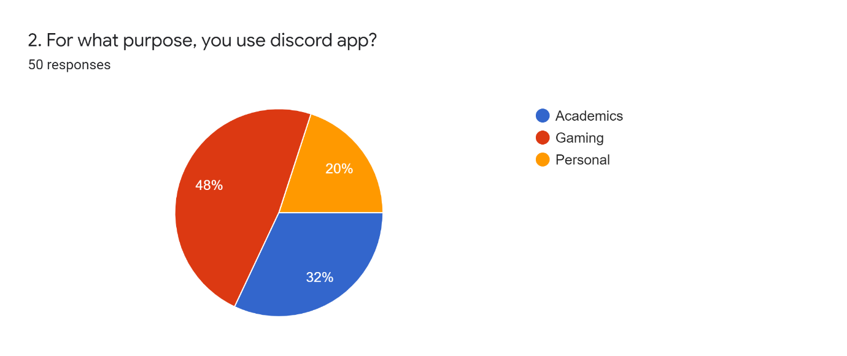

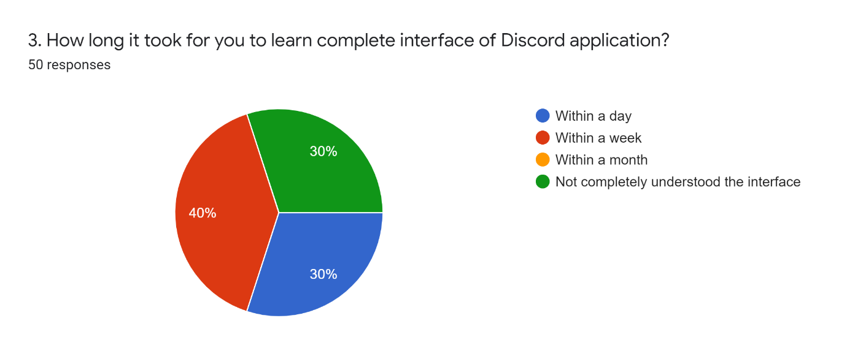

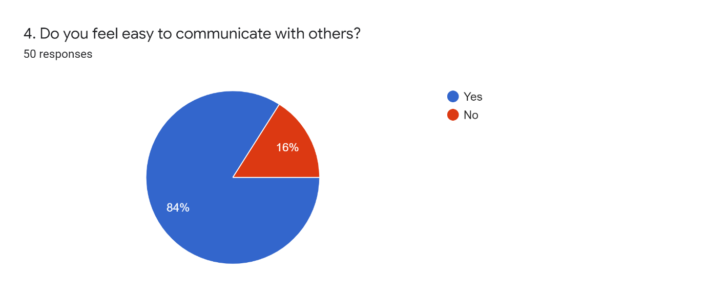

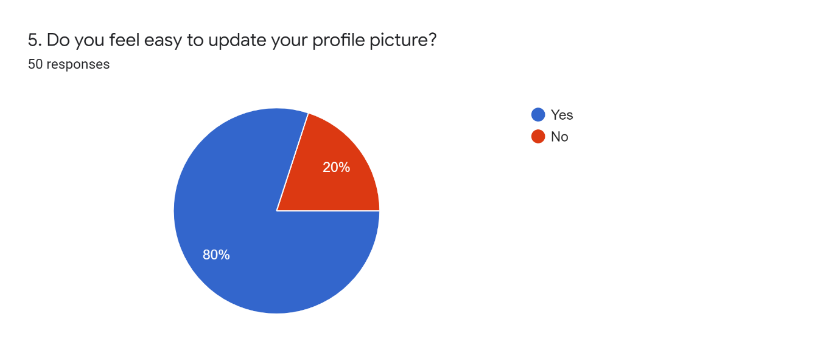

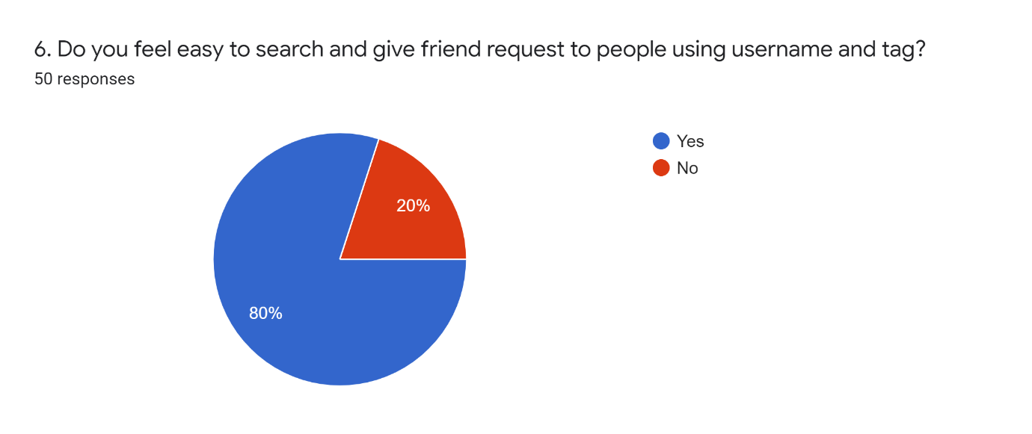

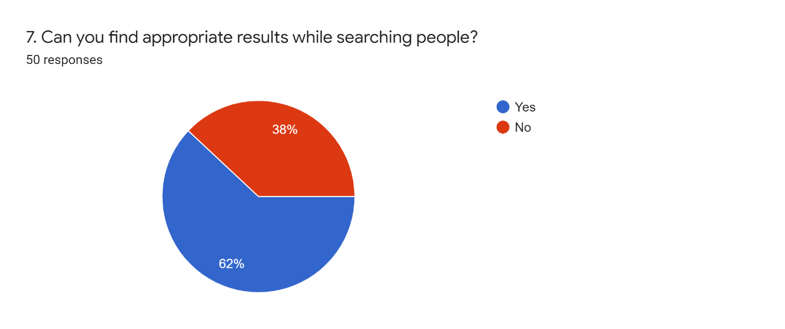

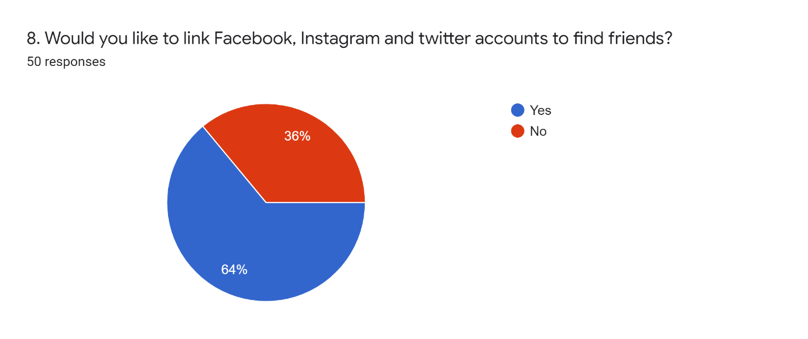

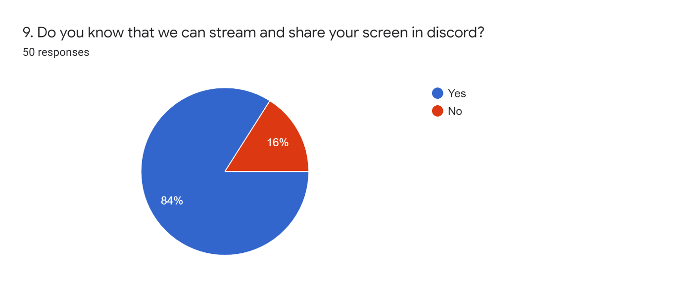

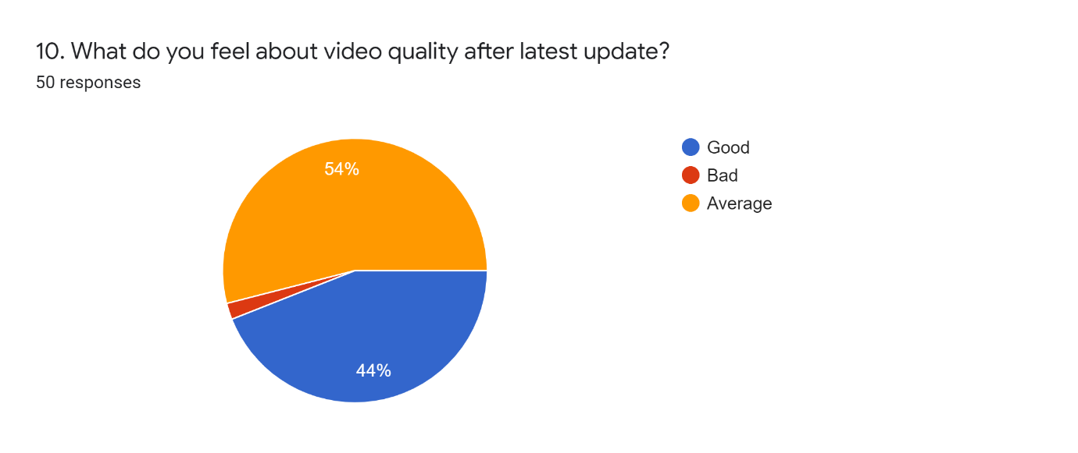

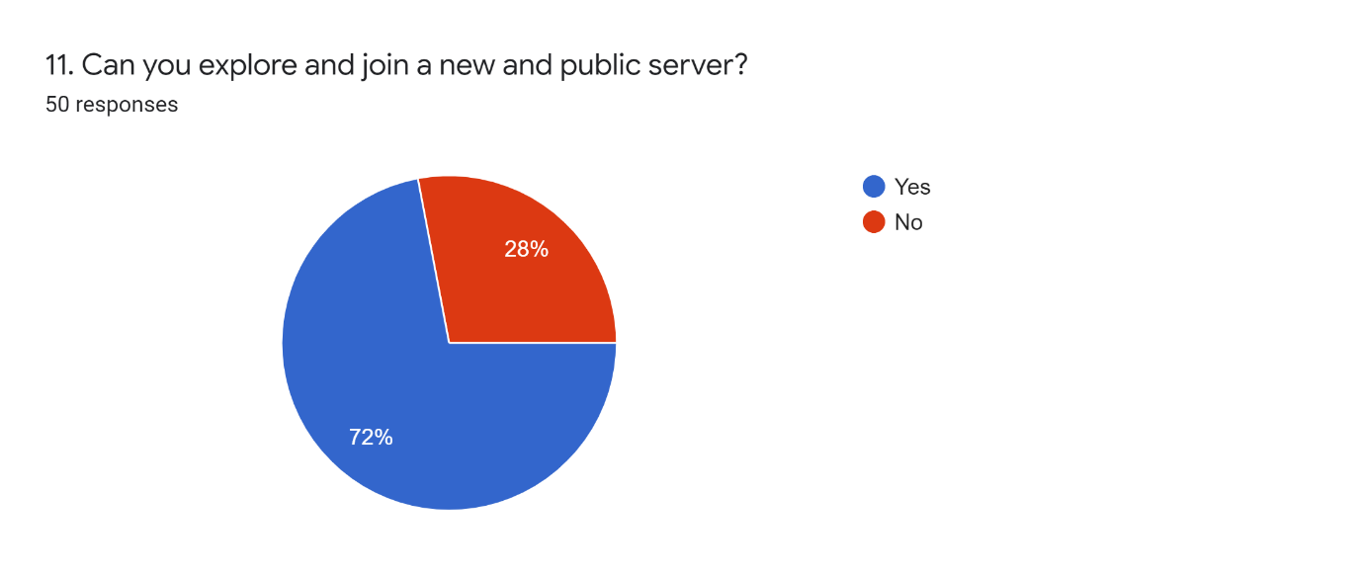

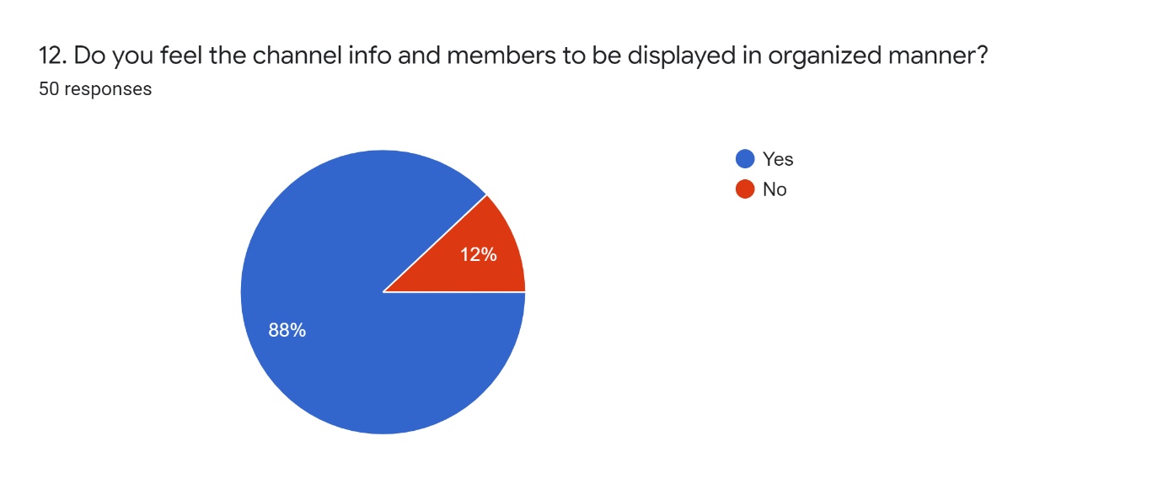

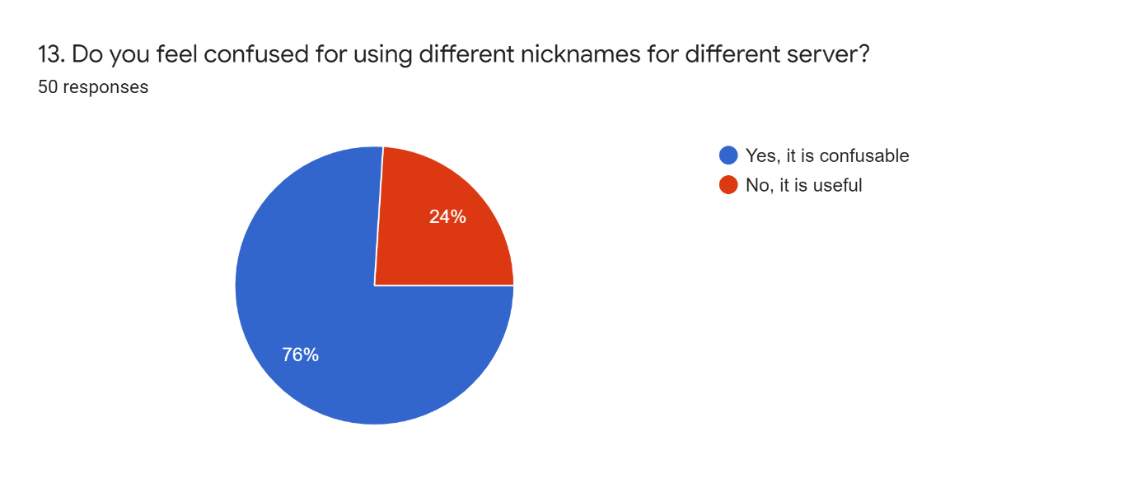

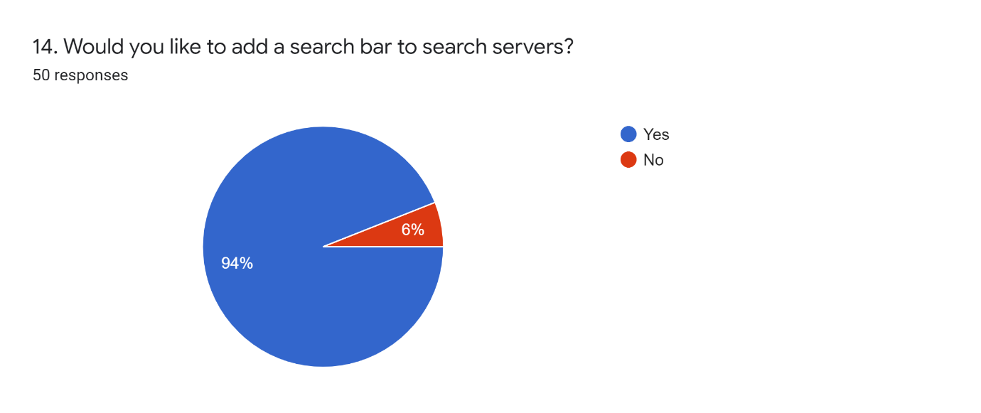

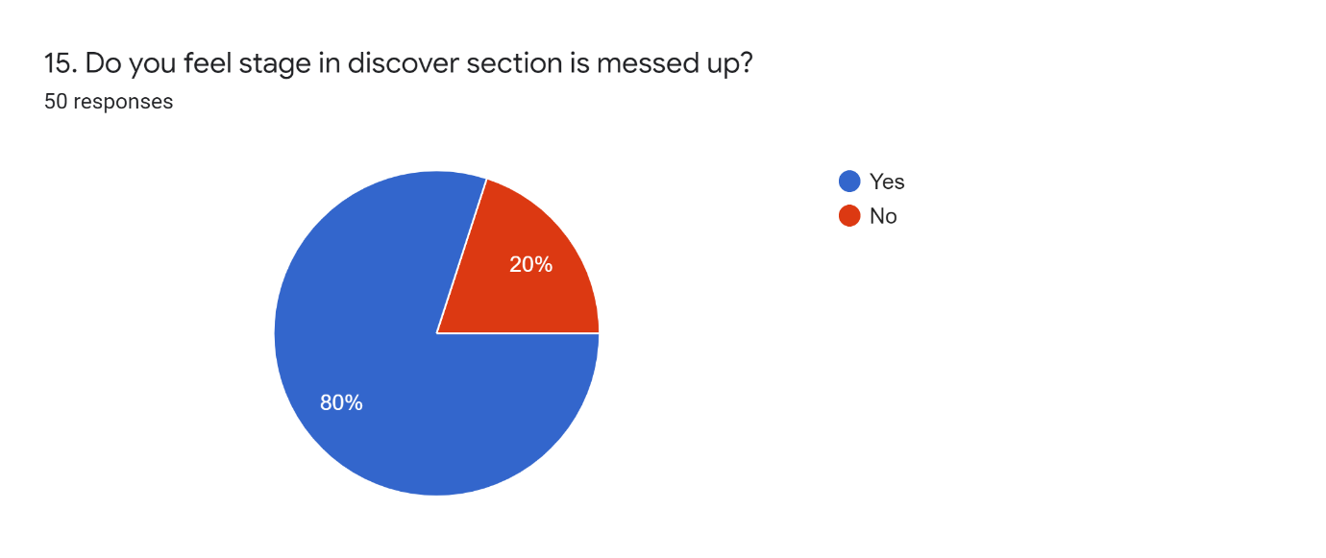

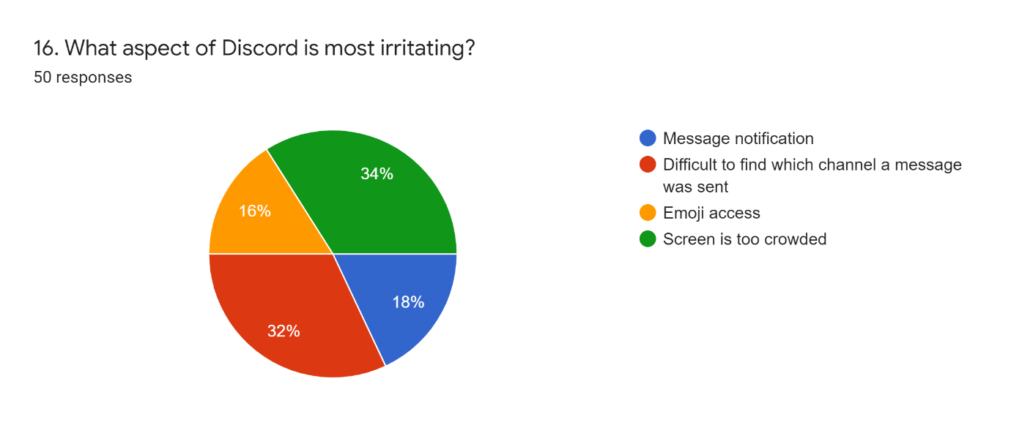

**17. What is the unique feature you particularly like in discord?**

* Different workspace for different purposes is good.
* Free chat and video servers along with unique feature for gaming
* The Unique feature that I like in discord app is, great way to communicate with friends during playing any games

**18.Any Features you want to add in Discord to make it easier to use.**

* To join in global server by searching.
* Voice Message Option is missing in Discord App
* Connecting with social media will helps us to connect people from that plat form it will easy to to know that how many of our friends using discord or not for games or any else
* Make it look easy like Instagram
* Nope
* Nothing
* Interface improvement
* Chat heads.
* User interface for newbies to be much friendly.
* Nothing
* Video
* Search bar
* Already it's has up to date features
* To have some features like in YouTube.
* Screen sharing and make regular announcement
* Make it a little organised

**Google forms link:**

[**https://forms.gle/FizjPW6JQfpJuaEp7**](https://forms.gle/FizjPW6JQfpJuaEp7)

**Response link:**

[**https://docs.google.com/spreadsheets/d/1ewTj5vE8pG-vSWlQcA9j8iNpBSHcYrG71XMwYzbgk3A/edit?usp=sharing**](https://docs.google.com/spreadsheets/d/1ewTj5vE8pG-vSWlQcA9j8iNpBSHcYrG71XMwYzbgk3A/edit?usp=sharing)

**3. Review-2 (Design of Diagrams & Prototype Design)**

**Requirements Gathering**

**Functional Requirements for Discord app:**

**1. Login**

**Use case:** Login

**Primary Actor:** User

**Goal in context:** Accessing Discord account

**Scenario:**

The system asks user for their credentials.

**2. Personal chat**

**Use case:** Chat with other users

**Primary actor:** User

**Goal in context:** Chat with others in this platform.

**Scenario:**

User has to enter the username and tag used in this platform

**3. Joining in servers**

**Use case:** Joining in servers

**Primary actor:** User, Server Admin/Moderator

**Goal in context:** Join into the public servers

**Scenario:**

User can enter server link provided by the owner/moderator.

**4. Creating a Server**

**Use case:** Creating a new server.

**Primary actor:** User

**Goal in context:** User can create new servers for their own purpose.

**Scenario:**

User can create their own server under gaming, school club, local community, friends, artist or creator, study group.

**5. Subscription**

**Use case:** Buy subscription using money

**Primary actor**: User

**Goal in context:** By activating subscription, user can access various features.

**Scenario:**

Users can access specific emoji, stickers for specific servers. the more they buy nitro, they can join in more servers. Also, user can support the server and the creator.

**6. Voice channel**

**Use case:** Accessing voice channels

**Primary actor:** User, Server participants

**Goal in context:** Users can participate in audio meetings

**Scenario:**

Users can join, listen/speak in audio meetings with the participants

**7. Language**

**Use case:** Changing language

**Primary actor:** User

**Goal in context:** By default, English (USA) is applied in that app. We can choose desired language

**Scenario:**

Click user settings, in that we can find Language under app settings. We can choose desired language available in it.

**8. Profile**

**Use case:** User profile

**Primary actor:** User

**Goal in context:** Update/change user profile

**Scenario:**

By clicking user settings, we can find user profile option. In that we can add description about us, and changing profile picture.

**9. Connections**

**Use case:** Connections

**Primary actor:** user

**Goal in context:** Use discord in multiple devices

**Scenario:**

User can access their account through mobile, desktops by giving permissions and adding devices to an account.

**10. Organization**

**Use case:** Organization/institution

**Primary actor:** User

**Goal in context:** User can join in their college/school discord server.

**Scenario:**

User can join school/college study and students club by entering the official mail address provided by the institution.

**11. Inviting members**

**Use case:** Inviting members to a server

**Primary actor:** User, Admins

**Goal in context:** only owner and moderator can add members to a server

**Scenario:**

User can join a server by using a link provided by the administrator of the server only if it is a public server. Otherwise, users have to request to join the server. Then admins will approve our request to join the server

**12. Roles**

**Use case:** Giving roles to members

**Primary actor:** User, Admin

**Goal in context:** Only admins can assign roles for their server.

**Scenario:**

The owner of the server has all permission to access the server. He will give some accessibilities to some users called moderators to monitor the other users’ contents and behaviour.

**13. Notification**

**Use case:** Notifications

**Primary actor:** User

**Goal in context:** Enable push notifications

**Scenario:**

Users have to enable the push notification in their mobile to get updated. They can enable push notifications for mentions, general chat, announcements, live/voice chat, etc.,

**Non-Functional Requirements for Discord app:**

**1. Availability:**

The web version and the mobile application should be responsive to the user all the time.

**2. Adaptability:**

a) The finished application and the server must allow new user to sign in.

b) The application must be flexible to use.

**3. Aesthetics:**

a) The colour of the text must be suitable with the background colour, which could be visible and easy to read.

b) The application and the web version must have a light and a dark theme. Which could be chosen by the user on their free will.

**4. Compatibility:**

The application should be compatible in all devices. Like smartphone, laptop, tablet, iPad, Mac, windows etc.,

**5. Consistency:**

a) The application and web version should be consistent in all aspects.

b) Also, the application must sync with all the devices where the account is used.

**6. Understandability:**

A novice user must able to understand the features and steps easily.

**7. Frequency:**

Even though millions of users use the application at a time, the application should not get crashed.

**8. Human factors:**

a) The User-Interface of the application should not be difficult.

b) Users should understand and can able to use all features

**9. Installability:**

a) The application should be available/compatible for all operating systems like Android, IOS, Windows.

b) The application should be easy to install in devices.

**10. Localizability:**

a) The application and the web version should be available in all languages.

b) All user interface components must be able to understand the system and if not, available it must use the common language (English).

**11. Maintainability:**

A separate team should be available to defects in the application.

**12. Predictability:**

The web version and mobile should never crash.

**13. Recoverability:**

a) When we close the application and re-open it, it should be in working state

**14. Reliability:**

The system should be available with all features all the time.

**15. Response Time:**

The query response time and action take time must be fast.

**16. Security:**

a) Only the account holder should be able to access the account and modify his account.

b) Only owners and moderators should be monitoring the server.

c) Also, the developers should provide a security patch update frequently.

**BEFORE RE-DESIGN:**

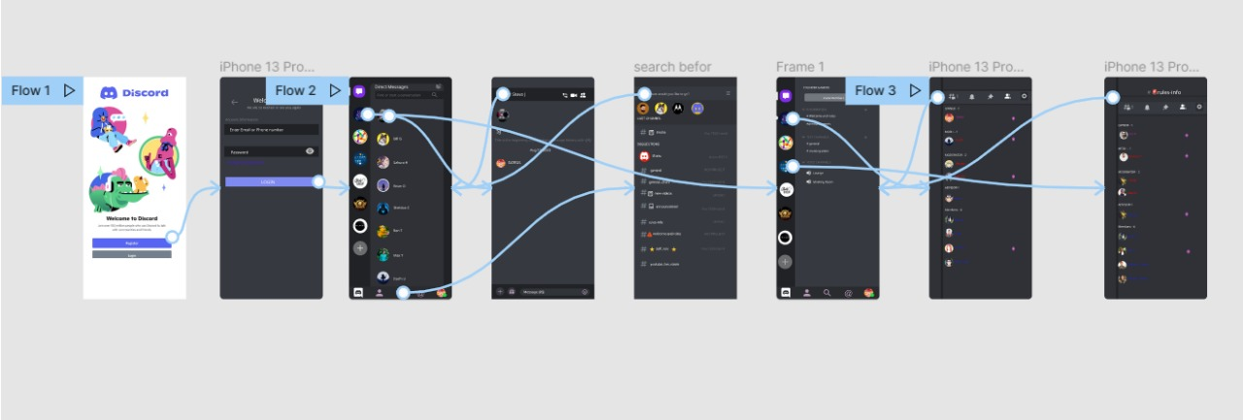

**AFTER RE-DESIGN:**

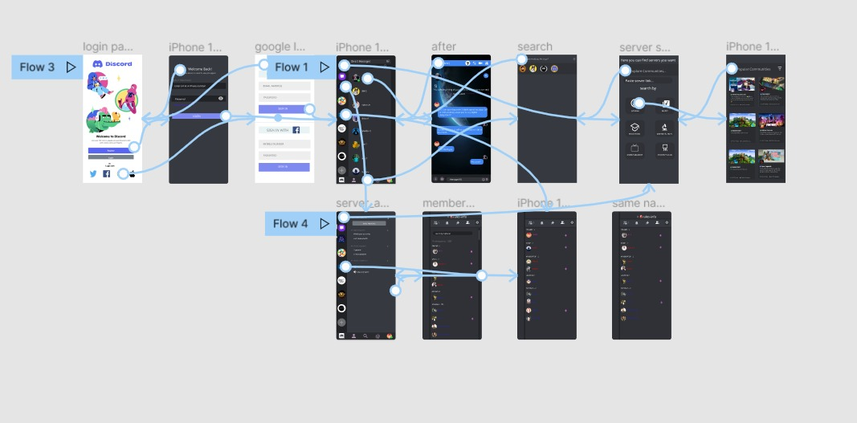

**Preview link:**

[**https://www.figma.com/proto/MWJyvQTahvg6L3MG69pf1p/DISCORD?node-id=142%3A156&scaling=scale-down&page-id=0%3A1&starting-point-node-id=142%3A156&show-proto-sidebar=1**](https://www.figma.com/proto/MWJyvQTahvg6L3MG69pf1p/DISCORD?node-id=142%3A156&scaling=scale-down&page-id=0%3A1&starting-point-node-id=142%3A156&show-proto-sidebar=1)

**ADDED ICONS:**

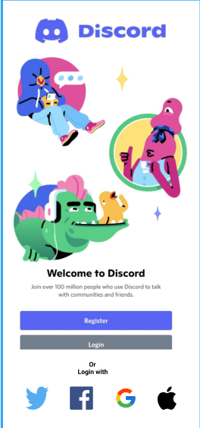 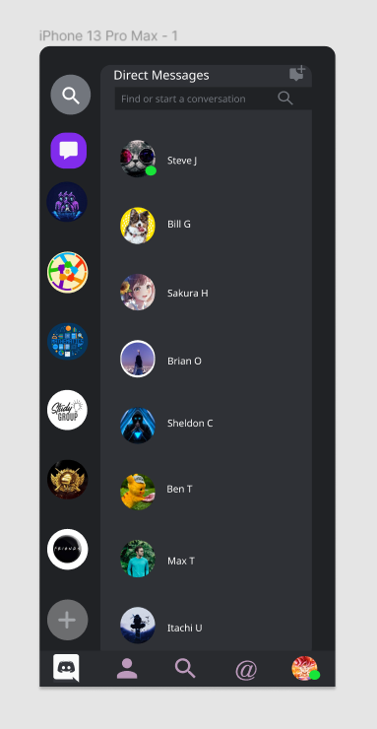

Added multiple log in features Added server search bar to find server easily.

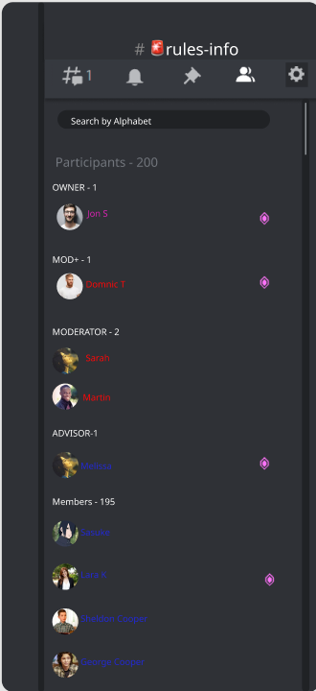 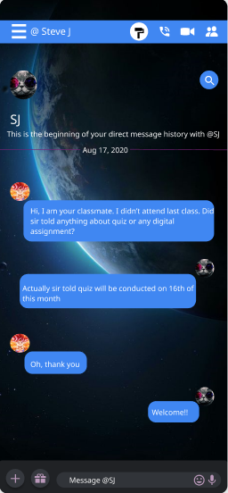

Added search bar to find members in server Added themes and voice message feature

**REVIEW-3**

**EVALUATION OF THE PROJECT:**

A heuristic evaluation is a usability inspection method for computer software that helps to identify usability problems in the user interface (UI) design. It specifically involves evaluators examining the interface and judging its compliance with recognized usability principles (the "heuristics").

**1. Visibility of system status.**

• The design should always keep users informed about what is going on, through appropriate feedback within a reasonable amount of time.

• When users know the current system status, they learn the outcome of their prior interactions and determine next steps.

**2. Match between system and real world.**

• The design should speak the users' language. Use words, phrases, and concepts familiar to the user, rather than internal jargon. Follow real-world conventions, making information appear in a natural and logical order.

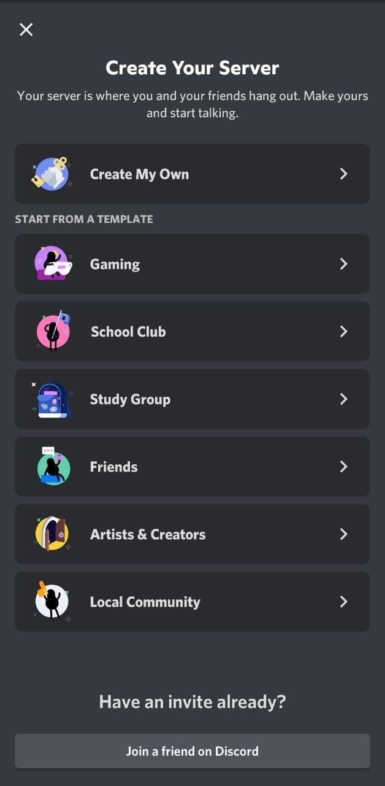

**3. User control and freedom.**

• Users often perform actions by mistake. They need a clearly marked " exit" to leave the unwanted action without having to go through an extended process.

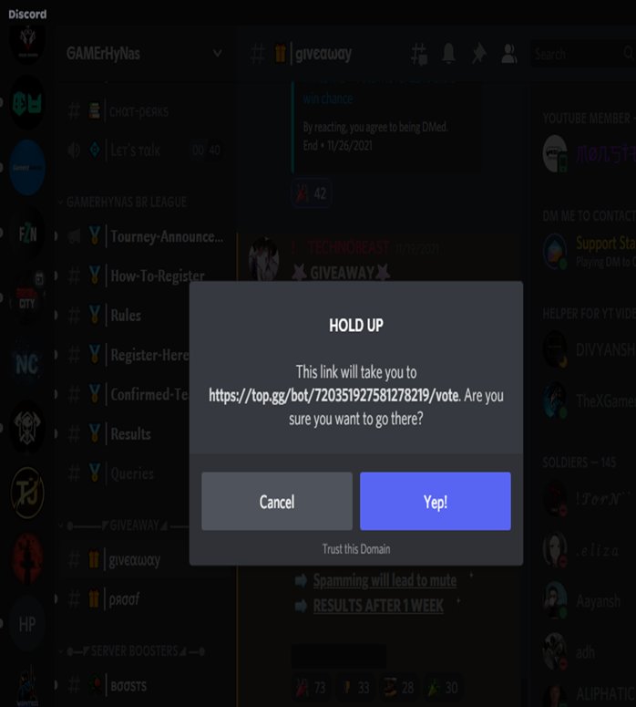

**4. Consistency and standards:**

• Users should not have to wonder whether different words, situations, or actions mean the same thing.

• Consistency concerned with making sure elements in a user interface are uniform. They'll look and behave the same way. This helps users for creating a sense of control, familiarity, and reliability.

• Users will get control in using this app if it is consistent.

**5. Error prevention:**

• Good error messages are important, but the best designs carefully prevent problems from occurring in the first place.

• Either eliminate error-prone conditions, or check for them and present users with a confirmation option before they commit to the action

• Using design patterns that encourages users to double check their work (especially before deleting) and want before mistakes are made.

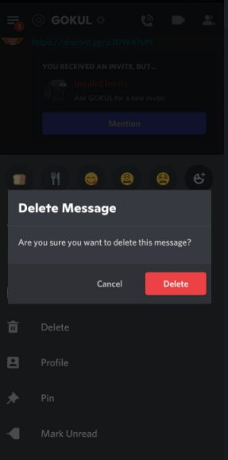

**6. Recognition rather than recall:**

• Minimize the user's memory load by making elements, actions, and options visible. The user should not have to remember information from one part of the interface to another.

• The design should not give burden to users and should reduce Short-term memory load of users.

• Information required to use the design (e.g., field labels or menu items) should be visible or easily retrievable when needed.

**7. Flexibility and efficiency of use:**

• The Interface should be flexible transforming itself between a novice user and an advanced user.

• One frequents this option while installing a new software that asks if the user wants to go ahead with default installation or custom installation.

• An advanced user chooses a custom installation to cut out the unnecessary services.

• Grab users’ attention towards the action need to be done there. Or give exact data that they want to see. Don't put irrelevant data and elements to confuse the users.

**8. Aesthetics and Minimal design:**

• Interfaces need to be cleared of unnecessary elements and content that do not support the page goals and tasks.

• Prioritization comes to play when this aspect is being considered. For the designer or the developer, all the information that’s being presented on the page is relevant.

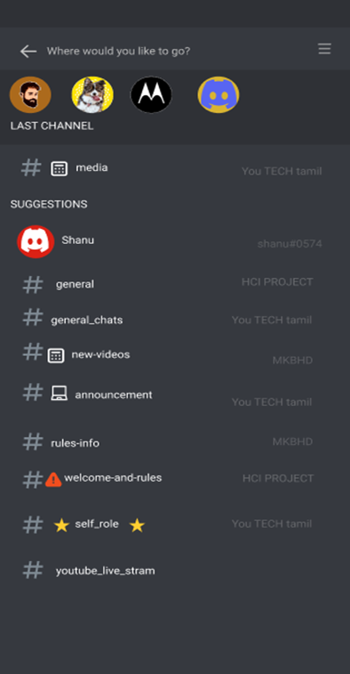

Before re-design, there will a lot of suggestions appear while we type. These suggestions are the mixture of personal chats as well as servers.

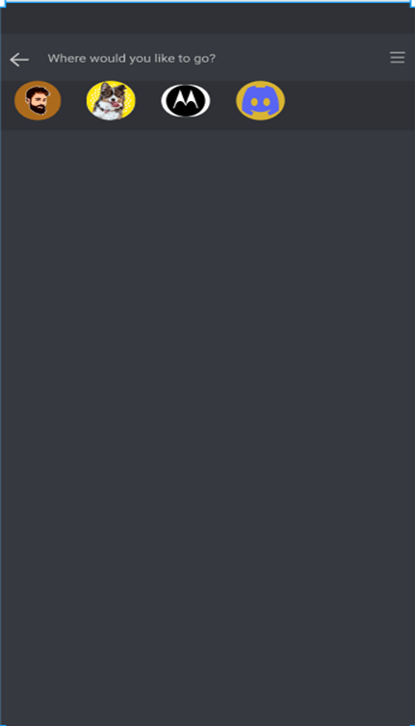

After re-design, we removed all the suggestions before we type something. It will show the results after we type. Also, shows where it is present.

**9. Help users recognize, diagnose and recover from errors:**

• Help the users to identify what is the exact error and suggest a way to get rid of that.

• A check needs to be made if those errors are being explained to the user in understandable language.

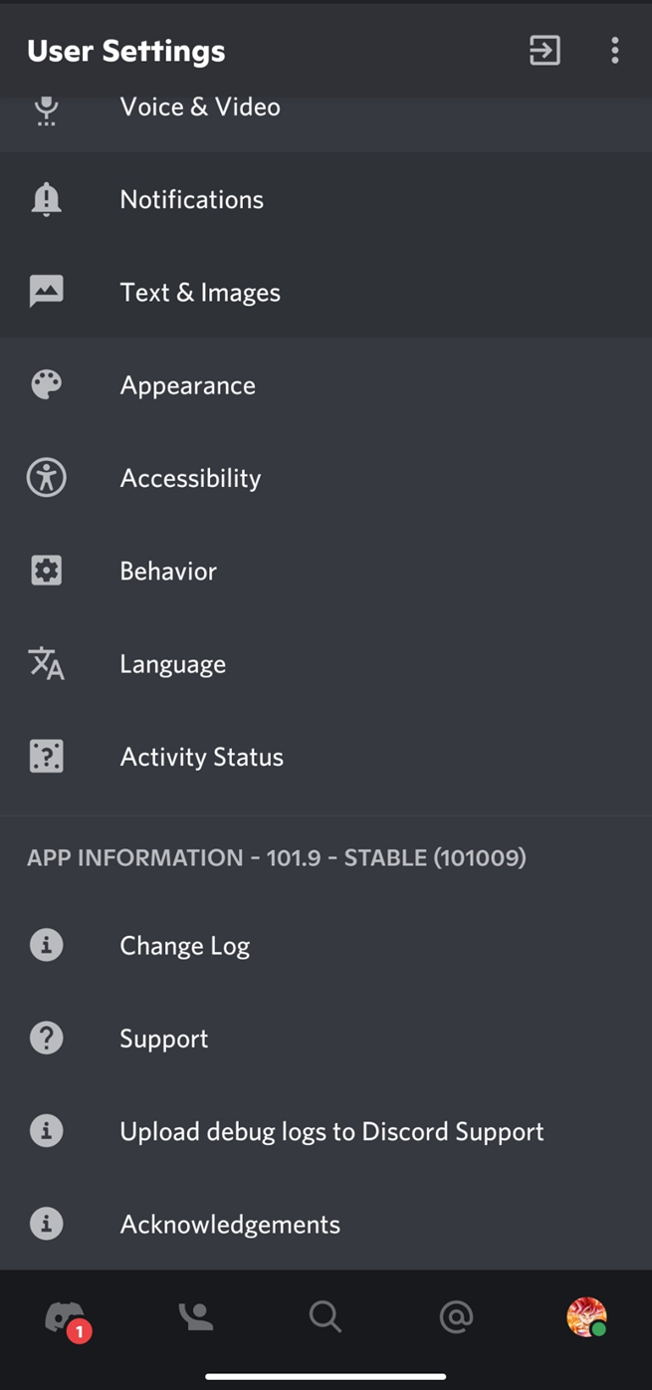

This option helps user to send their bugs in discord app to the maintenance team. They will fix our issues.

**10. Help and documentation:**

• If a user has reached this step, something is not right with the interface.

• A great user interface lets the user navigate through its features without any documentation or training.

• But if there is any user who could not make it out, adequate help should be provided within the product.

• If we still think that our design is perfect, then we need to put more attention towards those kinds of users.

• This is why help and documentation are very important for better user experience.



With the help of support option, user can contact/arise complaints.

**CONCLUSION:**

In this 21st century, humans don’t have enough time to complete their work. So, they prefer to reduce the time spending in some particular system. Here comes Human Computer Interaction, in those human and app interactions, humans should feel those apps are made for them to simplifies their tasks not to complicate them. Here HCI principles plays an important role in that, here we created the modified version of the Discord, which is not just a chatting application, rather it is profession for some game streamers and community maintainer. The enhanced prototype will meet nearly all of the requirements of the users.

**References:**

<https://www.youtube.com/watch?v=T5rJlhOGz9I>